BDSC 340.401 – Operations Management Fall 2018

Assignment 5
Instructions:
a) Show all the steps followed to arrive at the answer.
b) Submit your assignment 1on blackboard or through email by 10:00 pm on Thursday, October 18.

1. Solve the Problem 6.3, 6.5 and 6.7.

Question 6.3
Highest to lowest order of frequency
Col. 1 | Col. 2 | Col.3 | Col.4 | Col. 5 | Col. 6 | Col. 7
Rank | Reason code | Reason description | Frequency | % Frequency | Cumulative Frequency | % Cumulative Frequency
1 | C | Difficulty understanding material | 25 | =(25/68 x100)  = 36.76 % | 25 | 36.76 %
2 | A | Insufficient preparation time | 15 | = (15/68)x100  = 22.06 % | = (25 + 15)  = 40 | = (36.76+22.06)  = 58.82 %
3 | F | Distraction in exam room | 9 | = (9/68) x100  = 13.24 % | = (40 +9)  = 49 | = (58.82 + 13.24)  = 72.06 %
4 | B | Late arrival to Exam | 7 | 10.29 % | 56 | 82.35 %
5 | J | Felt ill during exam | 4 | 5.88 % | 60 | 88.23 %
6 | H | Forgot exam was scheduled | 3 | 4.41 % | 63 | 92.64 %
7 | D | Insufficient preparation time | 2 | 2.94 % | 65 | 95.58 %
8 | E | Studied wrong material | 2 | 2.94 % | 67 | 98.52 %
9 | G | Calculator batteries died during exam | 1 | 1.47 % | 68 | 99.99 %
 |  |  | 68

Question 6.5

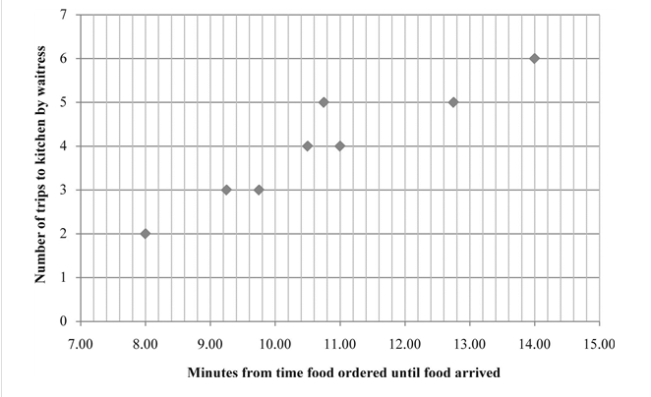
It is an example of a scatter graph

Question 6.7
Find in spreadsheet attached

